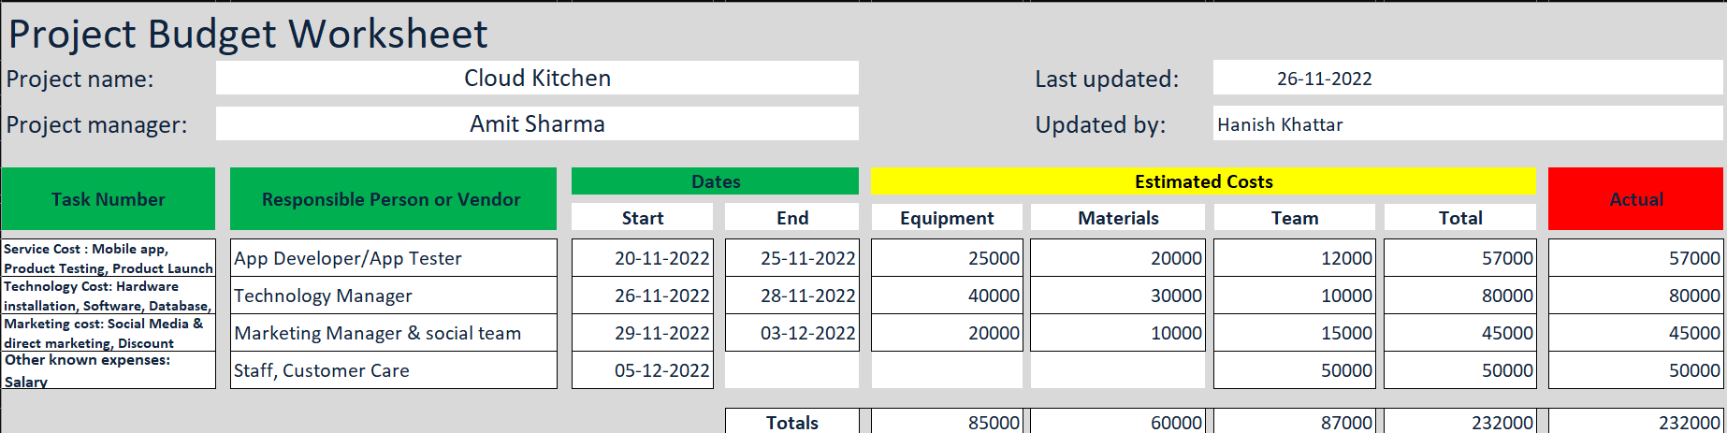

Project Budget for Cloud Kitchen

PROJECT BUDGET and COST

- New Service Cost
Mobile App & Desktop Website

$25000.00

Product Testing $20000.00
Product Launch $12000.00
New Service Cost Subtotal $57,0000

Technology Cost
Hardware Installation | $40000.00
Software | $20000.00
Database | $10000.00
Server Installation | $10000.00
New Technology Cost Subtotal | $80,000.00

- Marketing Cost
Social Media Marketing | $20000.00
Discount Offers | $10000.00
Unknown Cost  Marketing Cost Total | $15000.00
New Marketing Cost Total | $45,000.00

EXPENSES TOTAL $182,500.00

OTHER KNOWN EXPENSES
Staff Salary $50,0000

TOTAL PROJECT BUDGET $232,000

